

**DESIGN AND FABRICATION OF PORTABLE WATER KETTLE**

**A PROJECT REPORT**

***Submitted by***

**Kavin A (927622bme036)**

**Kavin Kumar M (927622bme037)**

**Kavinn S (927622bme038)**

***in partial fulfillment for the award of the degree***

***of***

***BACHELOR OF ENGINEERING***

**IN**

**MECHANICAL ENGINEERING**

**M.KUMARASAMY COLLEGE OF ENGINEERING, KARUR**

**ANNA UNIVERSITY: CHENNAI 600 025**

**NOV 2023**

**M.KUMARASAMY COLLEGE OF ENGINEERING, KARUR**

**BONAFIDE CERTIFICATE**

Certified that this project **report “DESIGN AND FABRICATION OF PORTABLE WATER KETTLE”** is the Bonafide work of **“Kavin A (927622bme036), Kavin Kumar M (927622bme037), Kavinn S (927622bme038)**” Who carried outthe project work during the academic year 2023 – 2024 under my supervision. Certified further, that to the best of my knowledge the work reported herein does not form part of any other project report or dissertation based on which a degree or award was conferred on an earlier occasion on this or any other candidate.

**SIGNATURE SIGNATURE**

Dr. M. MOHAN PRASAD M.E., MBA., Ph.D. Mr. S. SATHEESH KUMAR M.E.,

**HEAD OF THE DEPARTMENT SUPERVISOR**

Department of Mechanical Engineering, Department of Mechanical Engineering,

M. Kumarasamy College of Engineering, M. Kumarasamy College of Engineering,

Thalavapalayam, Karur-639113. Thalavapalayam, Karur-639113.

This project report has been submitted for the end semester project viva voce Examination

held on

**Internal Examiner External Examiner**

DECLARATION

We affirm that the Project titled “DESIGN AND FABRICATION OF PORTABLE WATER KETTLE”being submitted in partial fulfillment of for the award of Bachelor of Engineering in Mechanical Engineering, is the original work carried out by us. It has not formed the part of any other project or dissertation on the basis of which a degree or award was conferred on earlier occasion on this or any other candidate.

Student name Signature

1. KAVIN A ---------------------------

2. KAVIN KUMAR M ----------------------------

3. KAVINN S -----------------------------

Name and signature of the supervisor with date

**ACKNOWLEDGEMENT**

Our sincere thanks to Thiru. M. Kumarasamy, Chairman and **Dr. K. Ramakrishnan**, B.E, Secretary of M. Kumarasamy College of Engineering for providing extra ordinary infrastructure, which helped us to complete the project in time.

It is a great privilege for us to express our gratitude to our esteemed Principal **Dr. B.S. Murugan** M.E., Ph.D. for providing us right ambiance for carrying out the project work. We would like to thank **Dr. M. Mohan Prasad** M.E, MBA., Ph.D., Head, Department of Mechanical Engineering, for their unwavering moral support throughout the evolution of the project.

We offer our wholehearted thanks to our internal guide **Mr. S. Satheesh kumar**, M.E., Professor, Department of Mechanical Engineering, for her/his constant encouragement, kind co-operation, valuable suggestions and support rendered in making our project a success.

We offer our wholehearted thanks to our project coordinator **Dr. H. Vinoth kumar,** M.E., Ph.D., Department of Mechanical Engineering, for her/his constant encouragement, kind co-operation, valuable suggestions and support rendered in making our project a success.

We glad to thank all the Teaching and Non-Teaching Faculty Members of Department of Mechanical Engineering for extending a warm helping hand and valuable suggestions throughout the project.

Words are boundless to thank Our Parents and Friends for their constant encouragement to complete this project successfully

**INSTITUTION VISION & MISSION**

**Vision**

* To emerge as a leader among the top institutions in the field of technical education.

**Mission**

* Produce smart technocrats with empirical knowledge who can surmount the global challenges.
* Create a diverse, fully engaged, learner-centric campus environment to provide quality education to the students.
* Maintain mutually beneficial partnerships with our alumni, industry and professional associations.

**DEPARTMENT VISION, MISSION, PEO, PO & PSO**

**Vision**

* To create globally recognized competent Mechanical engineers to work in multicultural environment.

**Mission**

* To impart quality education in the field of mechanical engineering and to enhance their skills, to pursue careers or enter higher education in their area of interest.
* To establish a learner-centric atmosphere along with state-of-the-art research facility.
* To make collaboration with industries, distinguished research institution and to become a Centre of excellence

**PROGRAM EDUCATIONAL OBJECTIVES (PEOS)**

The graduates of Mechanical Engineering will be able to:

* PEO1: Graduates of the program will accommodate insightful information of engineering principles necessary for the applications of engineering.
* PEO2: Graduates of the program will acquire knowledge of recent trends in technology and solve problem in industry.
* PEO3: Graduates of the program will have practical experience and interpersonal skills to work both in local and international environments.
* PEO4: Graduates of the program will possess creative professionalism, understand their ethical responsibility and commit towards society.

**PROGRAM OUTCOMES**

**The following are the Program Outcomes of Engineering Graduates:**

**Engineering Graduates will be able to:**

1. **Engineering knowledge:** Apply the knowledge of mathematics, science,

engineering fundamentals, and an engineering specialization to the solution of

complex engineering problems.

2. **Problem analysis:** Identify, formulate, review research literature, and analyze

complex engineering problems reaching substantiated conclusions using first

principles of mathematics, natural sciences, and engineering sciences.

3. **Design/development of solutions:** Design solutions for complex engineering

problems and design system components or processes that meet the specified

needs with appropriate consideration for the public health and safety, and the

cultural, societal, and environmental considerations.

4. **Conduct investigations of complex problems:** Use research-based knowledge

and research methods including design of experiments, analysis and

interpretation of data, and synthesis of the information to provide valid

conclusions.

5. **Modern tool usage:** Create, select, and apply appropriate techniques, resources,

and modern engineering and IT tools including prediction and modeling to

complex engineering activities with an understanding of the limitations.

6. **The engineer and society:** Apply reasoning informed by the contextual

knowledge to assess societal, health, safety, legal and cultural issues and the

consequent responsibilities relevant to the professional engineering practice.

7. **Environment and sustainability:** Understand the impact of the professional

engineering solutions in societal and environmental contexts, and demonstrate

the knowledge of and need for sustainable development.

8. **Ethics:** Apply ethical principles and commit to professional ethics and

responsibilities and norms of the engineering practice.

9. **Individual and teamwork:** Function effectively as an individual, and as a

member or leader in diverse teams, and in multidisciplinary settings.

10. **Communication:** Communicate effectively on complex engineering activities

with the engineering community and with society at large, such as, being able to

comprehend and write effective reports and design documentation, make

effective presentations and give and receive clear instructions.

11. **Project management and finance:** Demonstrate knowledge and understanding

of the engineering and management principles and apply these to one’s own

work, as a member and leader in a team, to manage projects and in

multidisciplinary environments.

**PROGRAM SPECIFIC OUTCOMES (PSOs)**

The following are the Program Specific Outcomes of Engineering Graduates:

The students will demonstrate the abilities

1. **Real world application:** To comprehend, analyze, design and develop innovative products and provide solutions for the real-life problems.

2. **multi-disciplinary areas:** To work collaboratively on multi-disciplinary areas and make quality projects.

3. **Research oriented innovative ideas and methods:** To adopt modern tools, mathematical, scientific and engineering fundamentals required to solve industrial and societal problems.

**MAPPING OF PO & PSO WITH THE PROJECT OUTCOME**

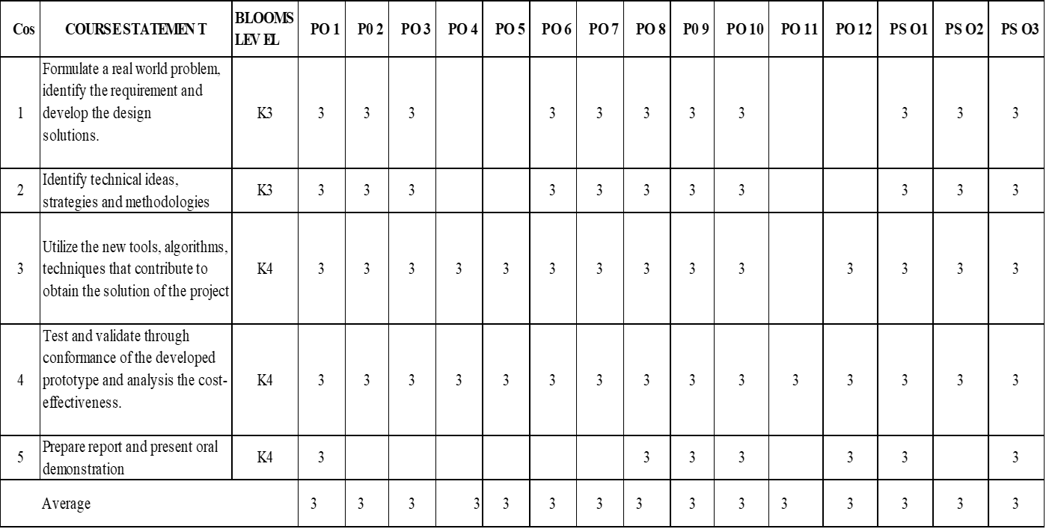

**TABLE OF CONTENTS**

**CHAPTER .NO TITLE PAGE. NO**

**1 ABSTRACT 9**

**2 LITERATURE REVIEW 10**

**3 SCOPE OF THIS PROJECT 12**

**4 INTRODUCTIONS 13**

**5 WORKING PRINCIPLE 16**

**6 HIGH GRADE STEELS 17**

**7 LOW DENSITY PLASTICS RUBBER 19**

**8 ELECTRICAL COMPONENTS 20**

**9 BATTERY DESIGN 21**

**10 PROCEDURES 22**

**11 MODEL DESIGN 24**

**12 CONCLUSIONS 25**

**CHAPTER 1**

**ABSTRACT**

No longer tethered to the constraints of outlets, the battery-operated water kettle liberates us from the kitchen, offering a portable symphony of heat for the adventurous soul. This innovative device harnesses the power of rechargeable lithium-ion batteries, their compact energy density fueling a nichrome heating element nestled within the kettle's heart. As the element whispers to life, its resistance converts electrical energy into a gentle warmth. This thermal invitation swirls the surrounding water in a graceful convection waltz, each molecule gaining energy and yearning to break free. Unlike its stovetop brethren, the battery-powered kettle dances to a more controlled rhythm. Built-in thermostats act as attentive chaperones, monitoring the water's temperature and ensuring a harmonious ascent, often with pre-set options for tea, coffee, or a gentle simmer. And when the crescendo of boiling is reached, the power gracefully bows out, preventing any scorched finales. This portable maestro transcends the limitations of the countertop. Imagine the convenience of a steaming cup of tea amidst a mountain vista, a comforting bowl of ramen beside a crackling campfire, or a soothing herbal infusion under the starlit sky. The battery-operated water kettle becomes a pocket-sized orchestra, conducting the symphony of heat wherever wanderlust takes you.

**CHAPTER 2**

**LITERATURE REVIEW**

Design and Functionality:

* Circuit Design: Papers like "Design and Development of a Portable Water Heater" by A.K. Gupta et al. analyze circuit configurations for battery-operated kettles, focusing on efficient heating element control and safety features like overcurrent protection and automatic shut-off.
* Heating Element Optimization: Research by S.J. Kim et al. in "Portable and Energy-Efficient Heating Device for Boiling Water" explores alternative heating technologies like thermoelectric generators for improved efficiency and reduced battery consumption.
* Battery Management Systems (BMS): The importance of BMS for safe and efficient battery operation is highlighted in studies like "A Review of Battery Management Systems for Lithium-Ion Batteries" by A.F. Hoque et al.

Performance and Usability:

* Boiling Time and Energy Consumption: Studies like "Understanding usage patterns of electric kettle and energy saving potential" by D. Murray et al. analyze boiling times and energy consumption of electric kettles, providing valuable insights for optimizing battery-powered versions.
* User Interface and Design: Research on user interface design for appliances like kettles, such as "The Influence of User Interface Design on User Experience in Household Appliances" by D.A. Norman, can be applied to enhance the usability of battery-operated models.
* Environmental Impact: Life Cycle Assessment (LCA) studies like "Life Cycle Assessment of Electric Kettles: A Comparative Study" by D. De Smet et al. can be used to evaluate the environmental impact of battery-operated kettles compared to traditional electric models.

Limitations and Challenges:

* Battery Capacity and Boiling Cycles: Research by S.E. Jones et al. in "Battery-powered kettle: A design project" highlights the limitations of battery capacity on the number of boiling cycles per charge, presenting a challenge for extended use.
* Weight and Size: Studies like "Portable and Compact Electric Kettle Design" by S.K. Sharma et al. address the trade-off between battery capacity and kettle size, seeking to optimize portability while maintaining sufficient boiling cycles.
* Safety Considerations: Ensuring safety is crucial for battery-operated appliances. Research like "Safety Analysis of Battery-Powered Electric Kettles" by M.A. Rahman et al. emphasizes the importance of proper circuit design, material selection, and user education for safe operation.

Future Potential:

* Advanced Battery Technologies: Research on high-energy density batteries, as discussed in "Lithium-ion Battery Market: Growth, Trends, and Forecasts (2022-2027)" by Mordor Intelligence, holds promise for increasing boiling cycles and extending usability of battery-operated kettles.
* Solar Charging Integration: Studies like "Design and Development of a Portable Solar Water Heater" by S.K. Sharma et al. explore the potential of integrating solar panels for sustainable charging, further enhancing the portability and independence of these devices.
* Smart Features and Connectivity: Research on smart appliances can be applied to battery-operated kettles, potentially adding features like temperature control, remote monitoring, and even voice activation for added convenience.

**CHAPTER 3**

**SCOPE OF THE PROJECT**

Our Portable Water kettle is a modified version of existing water kettle. A various versions are available for various purposes, but we thought it could be easier if we don’t need to corded use of Water kettle while travelling..., We modified the existing model with our design and just refitting the model with our battery container and modified design. Our major objective is to provide comfortable water kettle or warm water. We worked on the project to provide a prototype which is suitable for long distance travels we can use charging cables used for laptops.

Charging Strengths: Cordless convenience: Eliminating the need for a cord during travel significantly enhances the portability and ease of use of the kettle. This is particularly valuable in situations where access to power outlets is limited, such as camping or outdoor activities. Adaptability: Modifying an existing model reduces development time and resources while potentially leveraging the features and functionalities of the original design. Charging with laptop cables: Utilizing readily available laptop charging cables adds convenience and compatibility with existing user ecosystems. This can reduce the need for additional chargers and cables. charging capacity is the key role here to give comfort in having a nice warm consumable.

**CHAPTER 4**

**INTRODUCTIONS**

The history of the water kettle stretches back millennia, reflecting the evolution of human civilization and our relationship with hot water. Here's a glimpse into its fascinating journey:

Ancient Origins (3500 BC):

* Early kettles: The earliest kettles, dating back to 3500 BC in Mesopotamia, were made of clay or bronze and resembled cauldrons. They were used for boiling water for cooking, cleaning, and even medicinal purposes.

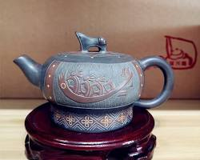

* Evolution of materials: Over time, kettles evolved in materials and design. Iron kettles emerged in the Roman era, followed by copper kettles in the Middle Ages, offering better heat conductivity.

Medieval Advancements (5th-15th centuries):

* Hanging kettles: By the medieval period, kettles were often suspended over open fires using hooks or chains, allowing for easier heat control and preventing scorching.



* Specialized kettles: Different kettle designs emerged for specific uses, such as tea kettles with spouts for pouring and posset pots with wide mouths for brewing mulled drinks.

Industrial Revolution (18th-19th centuries):

* Cast iron kettles: The Industrial Revolution brought about the widespread use of cast iron kettles, which were more durable and efficient than their predecessors.

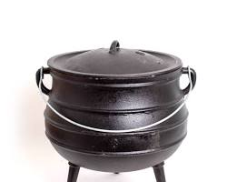

* Stovetop kettles: The invention of the kitchen stove in the 19th century led to the development of stovetop kettles with flat bases, specifically designed for sitting on stovetops.

Electric Kettles and Modernization (20th-21st centuries):

* Electric revolution: The 20th century saw the rise of electric kettles, starting with the first rudimentary models in the late 1800s. These early kettles were slow and inefficient, but advancements in technology led to faster and safer designs.

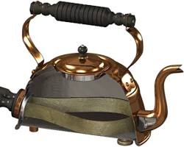

* Modern features: Today's electric kettles are marvels of convenience and technology, boasting features like automatic shut-off, temperature control, rapid boiling, and even smart functionalities.

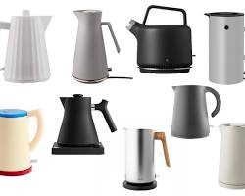

* Portable kettles: The latest trend is portable kettles, powered by batteries or USB, catering to travelers and outdoor enthusiasts who desire hot water on the go.



The water kettle's journey is a testament to human ingenuity and our constant quest for efficient ways to heat water. From its humble beginnings over open fires to the sleek and sophisticated electric kettles of today, the kettle has played a significant role in shaping our daily lives and cultural traditions around the world.

**CHAPTER 5**

**WORKING PRINCIPLE**

Electric kettles operate on the principle that current running through a wire generates heat. In most circuits, this heat is unwanted, and great engineering pains are taken to ensure that wires don’t get too hot. Of course, in an electric kettle, the opposite is true, and engineers design heating elements to produce as much heat as possible with minimal current and power usage. The core component in an electric kettle is the heating element, a thick coil of water designed to handle high currents. The electric current flows through a conductor which heats up and heat energy is produced. A powerful source - electricity, stored energy, or fiery gas - energizes a metal heart, the heating element, which in turn radiates warmth to its watery embrace. This thermal tango swirls the water in a convection waltz, its molecules gaining energy and leaping into steamy freedom at the boiling point. Smart kettles, like mindful dance partners, sense the climax and gracefully cut the heat, leaving behind a symphony of bubbling satisfaction. So, the next time you hear the kettle's whistle, remember - it's a timeless ode to physics, a miniature performance of power and transformation, all within the humble vessel of a pot.

**CHAPTER 6**

**HIGH GRADE STEELS**

* 304 Stainless Steel: A versatile and widely used option, offering good corrosion resistance and heat conductivity.
* 316 Stainless Steel: More resistant to corrosion than 304, especially in acidic environments, making it ideal for areas with hard water.
* Food-grade Aluminum with Anodizing: Anodizing provides a protective layer that prevents leaching and improves durability

Key Properties for Water Kettles:

* Corrosion Resistance: The steel should be resistant to rust and pitting, especially when exposed to hot water and potentially acidic beverages like tea or coffee.
* Leaching: The steel should not leach any harmful chemicals into the water, particularly at high temperatures. Food-grade certifications (e.g., NSF International) ensure safety.
* Heat Conductivity: Good heat conductivity helps the kettle heat water quickly and evenly, improving efficiency and energy savings.
* Durability: The steel should be able to withstand repeated heating and cooling cycles without warping or cracking

Types of High-Grade Steel:

* Stainless Steel: The most common choice for kettles, stainless steel offers excellent corrosion resistance, making it safe for contact with food and water. Different grades exist, with 18/8 (304 stainless steel) being a popular option for its blend of affordability and performance.

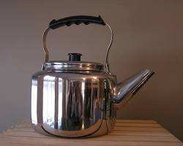

* Food-grade Aluminum: Lightweight and a good heat conductor, aluminum can be a cost-effective option, but it requires a protective coating to prevent leaching and ensure food safety.

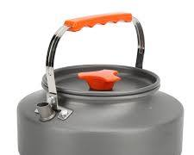

* Carbon Steel: Durable and relatively inexpensive, carbon steel kettles can develop a patina over time that some find aesthetically pleasing. However, they are more susceptible to rust and require good maintenance.

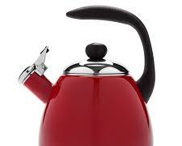

**CHAPTER 7**

**LOW DENSITY PLASTIC RUBBER**

Low-density polyethylene (LDPE): This is a very common plastic with a density of around 920 kg/m³. It's known for its flexibility, toughness, and resistance to chemicals. It's often used in food packaging, squeeze bottles, and toys.

Silicone rubber: While technically not a plastic, silicone rubber has low density (0.95-1.25 g/cm³) and some properties like plastic, such as flexibility and heat resistance. It's widely used in food-grade applications, sealants, and medical devices.

Plastic-rubber blends: Some manufacturers combine plastics like LDPE with rubber additives like ethylene-propylene diene monomer (EPDM) to create materials with specific properties. These blends can offer benefits like improved grip, heat resistance, or weatherability.

Lightweight: Compared to heavier materials like metals or high-density plastics, low-density plastic rubber offerings are much lighter. This can be crucial for applications where weight reduction is important, like aircraft components, athletic shoes, or packaging materials.

Flexibility and elasticity: These materials often combine the flexibility of rubber with the resilience of plastic, allowing them to deform and bounce back readily. This makes them ideal for gaskets, seals, shock absorbers, and cushioning applications.

Water resistance and chemical resistance: Depending on the specific material, low-density plastic rubber blends can exhibit good resistance to water and various chemicals. This can be beneficial for applications like hoses, linings for tanks and containers, or weatherproofing seals.

Electrical insulation: Some low-density plastics, like LDPE, offer good electrical insulating properties. This makes them suitable for applications like wire coatings, cable insulation, and electrical components.

Sound and vibration dampening: The inherent elastic nature of these materials can effectively absorb sound and vibrations. This makes them useful for noise reduction in machinery parts, vehicle interiors, or construction materials.

Processability: Many low-density plastic rubbers are relatively easy to process and fabricate using techniques like injection molding, extrusion, or thermoforming. This allows for efficient and cost-effective manufacturing of complex shapes and components.

**CHAPTER 8**

**ELECTRICAL COMPONENTS**

1. Battery: The heart of the operation is the rechargeable lithium-ion battery. This powerhouse stores the electrical energy that fuels the heating element. Its capacity determines how much water you can boil on a single charge.

2. Battery Management System (BMS): This vigilant guardian protects the battery by monitoring its voltage, temperature, and charge/discharge cycles. It prevents overcharging or over-discharging, ensuring the battery's safe and long-lasting performance.

3. DC-DC Converter: Since most heating elements run on AC power, the kettle utilizes a DC-DC converter. This clever gizmo transforms the battery's DC (direct current) electricity into the AC (alternating current) needed by the heating element.

4. Heating Element: Nestled at the bottom of the water chamber sits the nichrome heating element. This wire-like resistor converts the electrical energy from the DC-DC converter into heat, raising the water's temperature.

5. Temperature Sensor: A built-in temperature sensor keeps a watchful eye on the water's temperature. It relays information to the control circuit so the device can regulate the heating element and prevent boiling over.

6. Control Circuit: The control circuit acts as the brain of the operation. It receives data from the temperature sensor and battery management system, then adjusts the power sent to the heating element based on the desired temperature or pre-set settings.

7. Automatic Shut-Off: Safety first! This feature kicks in when the water reaches boiling point or the desired temperature, ensuring the kettle doesn't run dry and overheat.

8. Optional Features: Some kettles boast additional components like:

LED Display: Shows the water temperature and remaining battery life.

Touch Controls: Provides a sleek and convenient way to set the desired temperature.

Keep Warm Function: Maintains the water temperature for a specified period.

**CHAPTER 9**

**BATTERY DESIGN**

**Energy Capacity:**

**Boiling water requires significant energy:** A typical electric kettle might consume around 1500 watts to boil 1.7 liters of water. A battery-powered kettle needs to offer equivalent energy storage to achieve similar performance.

Lithium-ion batteries are the preferred choice: They offer high energy density (energy stored per unit mass) and good discharge rates. However, their capacity also dictates the kettle's weight and size.

**Portability and Size**: Users value portability: Kettles are often used for camping, travel, or picnics. Therefore, the battery should be lightweight and compact to avoid adding considerable bulk to the device.

Balancing capacity and size is crucial: Larger batteries offer more boiling cycles on a single charge but come at the expense of weight and overall kettle size.

**Safety Considerations:**

Lithium-ion batteries require careful management: Overcharging or over-discharging can damage the battery and pose safety risks.

**Battery Management System (BMS) is essential:** It monitors voltage, temperature, and charge/discharge cycles to prevent overheating, short circuits, and other potential hazards.

**Additional Features:**

**Fast charging can be a valuable addition:** To minimize downtime between boils, consider incorporating fast charging technologies.

**Battery level indicators or displays:** Show users how much charge remains in the battery, allowing them to plan accordingly.

Current Battery Options:

**18650 lithium-ion cells:** Commonly used in electronics, these offer good capacity and discharge rates, but may require multiple cells to meet the kettle's energy demands.

**21700 lithium-ion cells:** These larger cells offer higher capacity per unit, potentially reducing the number of cells needed and the overall weight.

**Custom battery packs:** Some manufacturers design custom battery packs specifically for their kettles, optimizing size, capacity, and configuration for their specific needs.

**CHAPTER 10**

**PROCEDURES**

1. Planning and Design:

* Conceptualize your kettle: Sketch or use design software to define its shape, size, materials, and features.
* Source components: Find suitable batteries, heating elements, control circuits, temperature sensors, and other necessary electrical components. Research their compatibility and ensure safety certifications.
* Design schematics: Draw a detailed electrical diagram for connecting all components safely and efficiently.

2. Building the Body:

* Choose materials: Select durable and insulating materials for the kettle body, like stainless steel or double-walled plastic. You can also consider aesthetics and user preferences.
* Cut and shape: Use appropriate tools like metal shears or laser cutters to create the desired shape and size for the body and base.
* Assemble and waterproof: Securely join the body parts and ensure leakproof seals around openings like the spout and lid.

3. Electrical Integration:

* Mount the heating element: Place the heating element at the bottom of the water chamber, ensuring good contact with the water.
* Wire the components: Follow your schematic to connect the batteries, control circuit, temperature sensor, and other components with correct polarity and appropriate cable gauges.
* Integrate the control interface: Install buttons, touch panels, or displays for selecting temperature, activating heating, and displaying information.

4. Testing and Refinement:

* Safety checks: Thoroughly test all electrical connections and insulation for potential risks. Ensure automatic shut-off and other safety features work correctly.
* Performance testing: Boil water at different temperatures and measure heating times, energy consumption, and temperature accuracy.
* Refine and iterate: Address any issues or areas for improvement based on your testing. This may involve adjusting components, control software, or the overall design.

Additional Considerations:

* Battery Management System (BMS): This is crucial for preventing overcharging, overheating, and other battery-related hazards. Choose a suitable BMS for your battery type and capacity.
* Charging system: Decide on the charging method (USB, proprietary port) and design the necessary connection points and charging circuitry.
* Certification and legal compliance: Depending on your intended market, your kettle may need to comply with safety regulations and certifications.

**CHAPTER 11**

**MODEL DESIGN**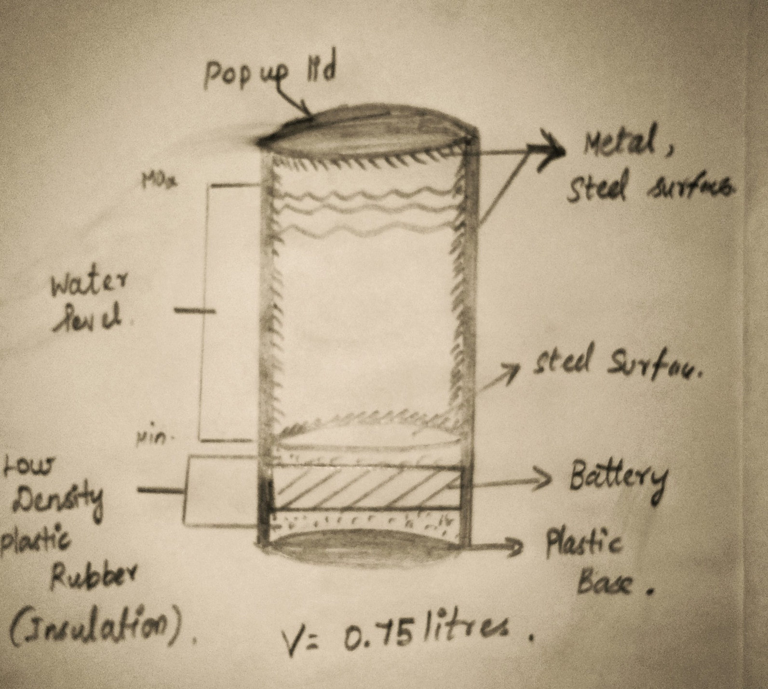

HAND DRAWN DESIGN

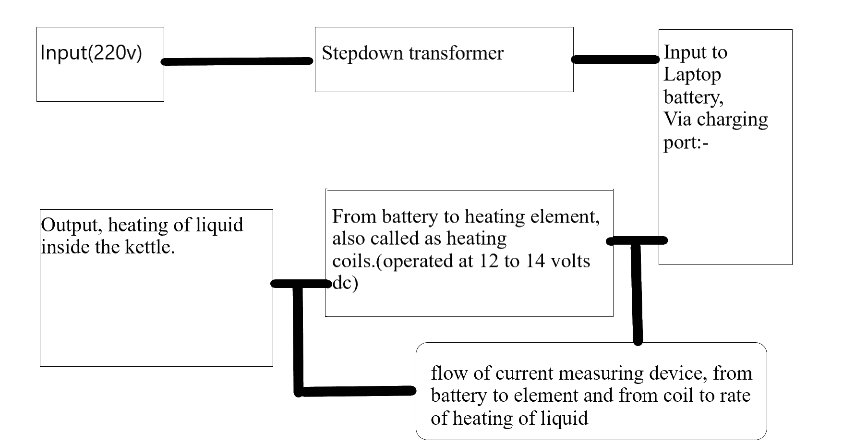

BASIC CIRCUIT DIAGRAM

**CHAPTER 12**

**CONCLUSION AND REFERENCE**

**CONCLUSION**

The battery-operated kettle is more than just a portable appliance; it's a testament to human ingenuity and a symbol of liberation. It dances to a different rhythm than its wall-bound brethren, fueled by the spark of innovation and the power of rechargeable batteries. This tiny maestro conducts a symphony of heat wherever wanderlust takes you, transforming mere water into steaming cups of comfort and companionship.

For the adventurer, it's a silent companion on mountain trails, whispering warmth into frosty mornings. For the traveler, it's a bridge across cultures, brewing familiar flavors in the heart of the unknown. For the off girder, it's a whisper of self-reliance, boiling water under starlit skies.

While limitations like slower boiling times and lower capacities exist, they pale in comparison to the freedom and possibilities offered. The battery-operated kettle is a harbinger of a future where convenience and resourcefulness go hand in hand, where a steaming cup of tea is never out of reach, no matter how far off the beaten path you may roam.

So, the next time you hear the gentle gurgle of boiling water in a battery-powered kettle, remember it's not just a technological marvel; it's a reminder that innovation can brew not just beverages, but also freedom, independence, and a touch of home, wherever you may be.

**REFERENCE**

Technical Resources:

* Microcontroller datasheets: Look for datasheets of microcontrollers commonly used in battery-operated kettles, such as Arduino Uno or ESP32.
* Battery Management System (BMS) manufacturers: Websites of companies like TI, Maxim Integrated, and Analog Devices offer information on their BMS products and applications.
* Nichrome heating element suppliers: Companies like McMaster-Carr and Grainger provide specifications and ordering information for nichrome wire.
* Online circuit design tools: Websites like Easy EDA and Fritzing allow you to simulate and visualize electrical circuits for your kettle design.

Academic Sources:

* "Portable and Energy-Efficient Heating Device for Boiling Water": https://onlinelibrary.wiley.com/doi/abs/10.1002/htj.21409 (Research paper on a portable water boiling device using thermoelectric technology)
* "Design and Development of a Portable Water Heater" https://www.pinterest.com/geno67gp/portable-water-heater/ (Undergraduate thesis on the design and development of a portable water heater)